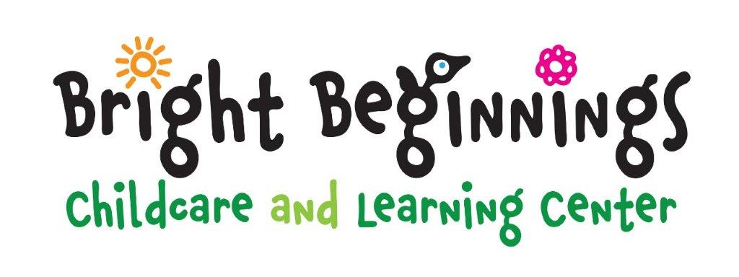

**Infant Program**

Five Days $295

Four Days $280

Three Days $250

Two Days $190

Daily $115

**Toddler Program**

Five Days $270

Four Days $255

Three Days $235

Two Days $184

Daily $105

**Younger Preschool Program**

Five Days $260

Four Days $250

Three Days $225

Two Days $184

Daily $100

**Older Preschool Program**

Five Days $255

Four Days $245

Three Days $220

Two Days $177

Daily $100

**Tuition Schedule**

**East Bethel Location**

**\*\*Effective: January 1, 2024\*\***

* There is a $75 registration fee per family due when registration is completed. $125 registration fee to hold an infant spot.
* **A 10% discount is given to the lower priced programs for families enrolling two or more children**
* Fees are due the 1st day of attendance each week.  A late payment of $40.00 will be charged for each week past due
* Breakfast, lunch and snack are included in the tuition unless otherwise indicated.
* Children picked up after normal closing time are subject a late fee of $25 for the 1st 15 minutes, then $15 every 15 minutes thereafter.
* No credits will be given when a child is sick or not attending their regular scheduled time.  This includes holidays and vacations.
* A two (2) week written withdrawal notice is required after the child has begun attending our facility.
* Return checks will be subject to a $40.00 surcharge.